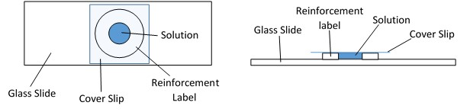

Glass Slide

Reinforcement Label

Cover Slip

Solution

Glass Slide

Cover Slip

Reinforcement label

Solution